TASK MANAGEMENT WEB APPLICATION

‘TASK_FLOW’

MOHAMED IHSHAS
TRI/IT/2324/F/47

Higher National Diploma in Information Technology
SLIATE

Sri Lanka Institute of Advanced Technological Education (SLIATE)
Advanced Technological Institute – Trincomalee

Date Of Submission
2026

Declaration

I declare that this report is my own work and has not been submitted in any form for another degree or diploma at any university or other institution of tertiary education. Information derived from the published or unpublished work of others has been acknowledged in the text and a list of references is given. "

A.M.Ihshas ………………..
Date :-

Supervised by
Thanushan ………………...
Signature of Supervisor
Date :-

Acknowledgements
I would like to express my sincere gratitude to my supervisor for their valuable guidance, continuous support, and constructive feedback throughout this project.
I am also thankful to the Advanced Technological Institute for providing the resources and learning environment necessary for completing this project.
Finally, I extend my heartfelt appreciation to my family and friends for their encouragement and support during the development of this project.

A.M. IHSHAS
TRI | IT | 2324 | F | 47

TASKFLOW – TASK MANAGEMENT WEB APPLICATION
FINAL PROJECT REPORT

ABSTRACT
TaskFlow is a web-based task management application developed using HTML, CSS, and JavaScript. The system allows users to create, edit, delete, and manage daily tasks efficiently. The application uses browser LocalStorage to store task data in JSON format without requiring a backend database.

The system includes features such as task prioritization, due date management, search and filtering functionality, and dashboard statistics that display total tasks, completed tasks, and overdue tasks. The application is fully client-side and works offline.

TaskFlow demonstrates practical implementation of modern front-end technologies and client-side data management techniques.

Table of Contents
- Introduction
1.1 Overview of TaskFlow
1.2 Objectives and Goals

- Literature Review
2.1 Overview of Existing Solutions
2.2 Key Challenges in Current Systems
2.3 Technologies Relevant to TaskFlow

- Project Methodology
3.1 Tools and Technologies Used
3.2 Development Process
3.3 System Architecture
3.4 Implementation Process

- Results and Discussion
4.1 System Functionality
4.2 User Interface and Design
4.3 Testing and Evaluation

- Risk Analysis

- Gantt Chart Explanation
- Conclusion
- References
- Appendices

List of Abbreviations

HTML – HyperText Markup Language
CSS – Cascading Style Sheets
JS – JavaScript
IT – Information Technology
HNDIT – Higher National Diploma in Information Technology
ATI – Advanced Technological Institute

Chapter 1: Introduction

1.1 Overview of Task_Flow
Task_Flow is a single-user task management web application designed to help individuals organize their daily activities effectively. The system allows users to create tasks, assign priorities, set due dates, update status, and track progress.

Unlike cloud-based systems, TaskFlow operates entirely in the browser using LocalStorage, eliminating the need for a backend server or database.

1.2 Objectives and Goals

• Provide a simple and intuitive task management system.
• Allow users to add, edit, and delete tasks.
• Enable task priority selection (Low, Medium, High).
• Provide due date tracking and overdue detection.
• Implement search and filtering features.
• Display dashboard statistics.
• Ensure offline functionality.

TaskFlow aims to improve personal productivity through structured digital task organization.

Chapter 2: Literature Review

2.1 Overview of Existing Solutions

Many modern task management systems exist, including:
• Todoist
• Microsoft to Do
• Google Tasks
• Trello

These platforms rely on cloud servers and databases to store user data. They provide synchronization across devices but require internet connectivity and user authentication.

2.2 Key Challenges in Current Systems

• Require internet connection
• Depend on backend infrastructure
• May involve subscription costs
• Complex setup for beginners

TaskFlow addresses these challenges by providing a lightweight browser-based solution.

2.3 Technologies Relevant to TaskFlow

Frontend Technologies
HTML – Defines structure
CSS – Controls design and layout
JavaScript – Implements logic and interactivity

Web Storage API
LocalStorage allows persistent client-side storage in JSON format.

Chapter 3: Project Methodology

3.1 Tools and Technologies Used

Frontend: HTML, CSS, JavaScript
Storage: LocalStorage
Development Tool: Visual Studio Code was the primary tool used for writing and editing the HTML and CSS code.


Browser Testing: Chrome, Edge, Firefox

3.2 Development Process

Planning – Defined system requirements and interface design.
Design – Created responsive UI layout and dashboard structure.
Development – Implemented CRUD operations and LocalStorage integration.
Testing – Tested across browsers and devices.

3.3 System Architecture

TaskFlow follows a client-side architecture:
Presentation Layer – HTML + CSS
Logic Layer – JavaScript
Storage Layer – LocalStorage
No backend or database is required.

3.4 Implementation Process

• Created structured HTML layout.
• Designed user interface using CSS.
• Implemented task management logic in JavaScript.
• Integrated LocalStorage for data persistence.
• Tested and debugged application.

Chapter 4: Results and Discussion

4.1 System Functionality

The system successfully allows:
• Task creation
• Task editing
• Task deletion
• Status update
• Priority assignment
• Overdue detection
• Dashboard statistics

4.2 User Interface and Design

The interface is clean, responsive, and user-friendly.
It includes:
• Dashboard cards
• Task input form
• Task list display
• Modal edit window

The design ensures smooth user interaction.

4.3 Testing and Evaluation

The application was tested for:
• Add task functionality
• Edit task functionality
• Delete task functionality
• Data persistence after refresh
• Filter and search operations

All tests were successful.

Chapter 5: Risk Analysis

Data Loss – If browser data is cleared, tasks will be lost.
Mitigation: Inform users and plan export feature.
Browser Compatibility – Different browser behaviors.
Mitigation: Cross-browser testing.
Development Delay – Time management issues.
Mitigation: Follow project schedule.

Chapter 6: Gantt Chart Explanation

The project development was divided into phases:
Requirement Analysis – Week 1
Design – Week 2
Development – Week 3–4
Testing – Week 5
Documentation – Week 6

The Gantt chart ensured proper scheduling and progress tracking.

Chapter 7: Conclusion

TaskFlow was successfully developed as a lightweight, browser-based task management system. The application meets all defined objectives and demonstrates effective use of front-end technologies.
The project proves that a fully functional web application can be developed without backend infrastructure.

Chapter 8: References
MDN Web Docs – Web Storage API

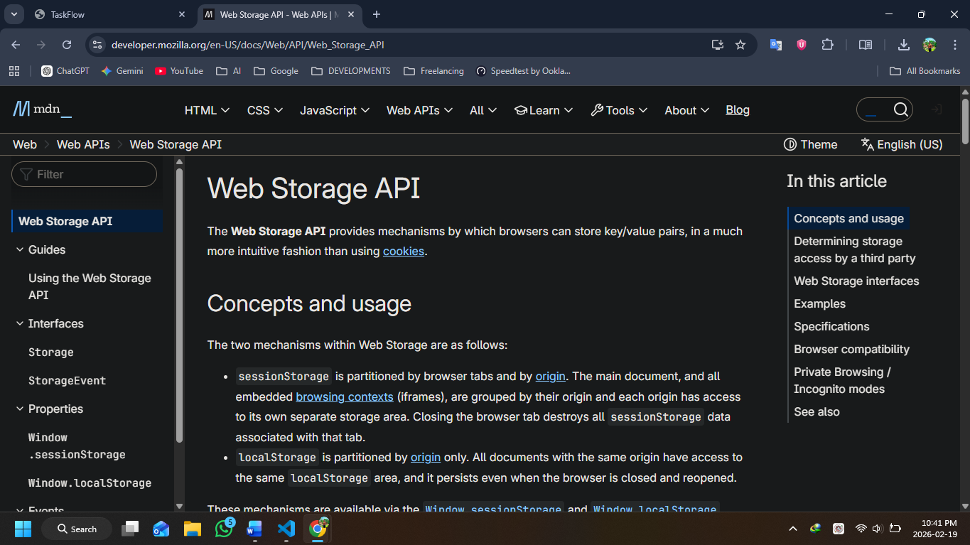
W3Schools – HTML, CSS, JavaScript

Chapter 9: Appendices
- HTML Code

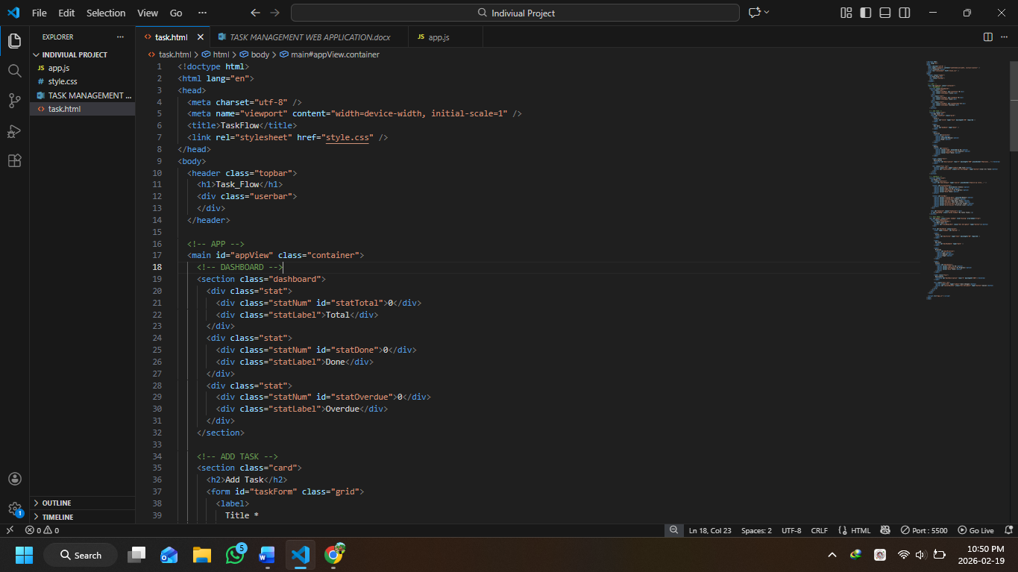

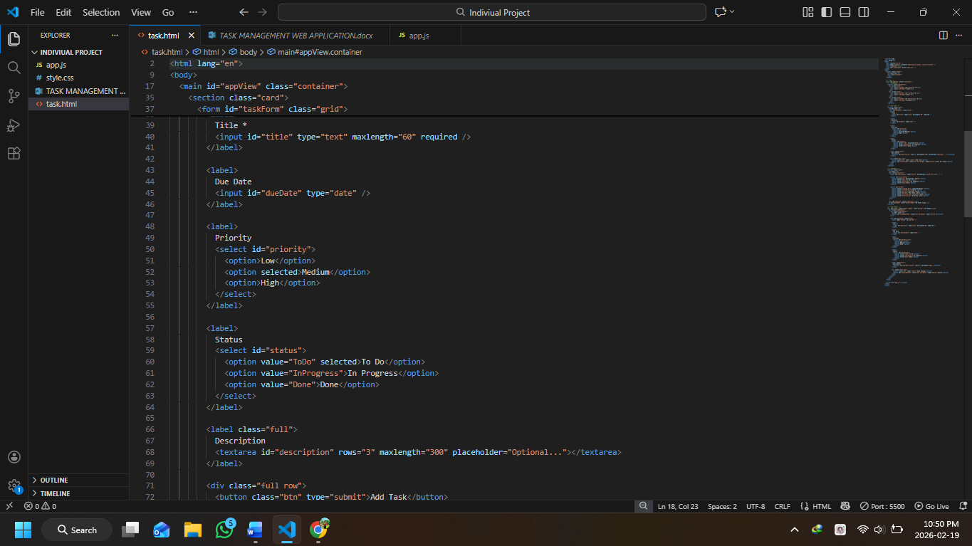
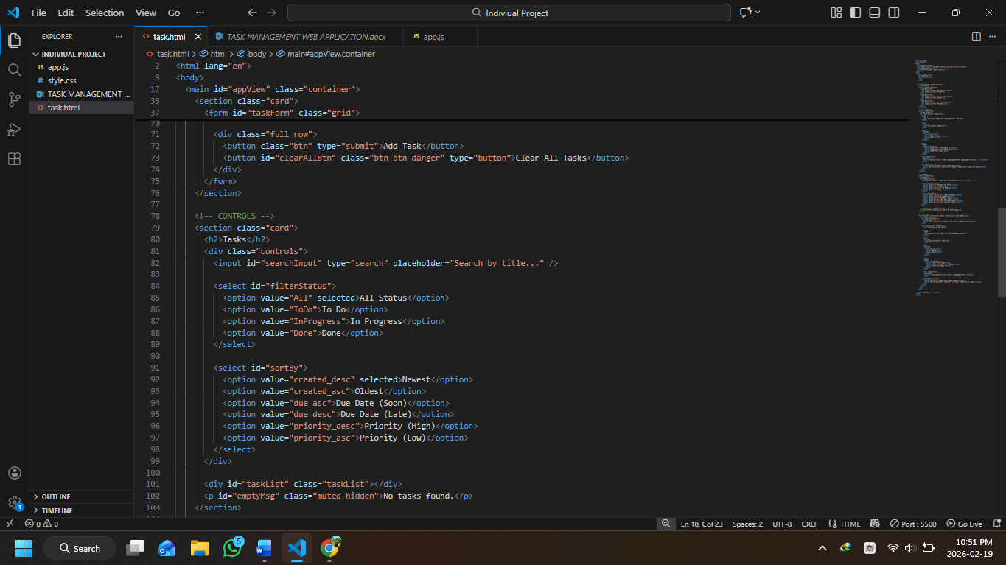

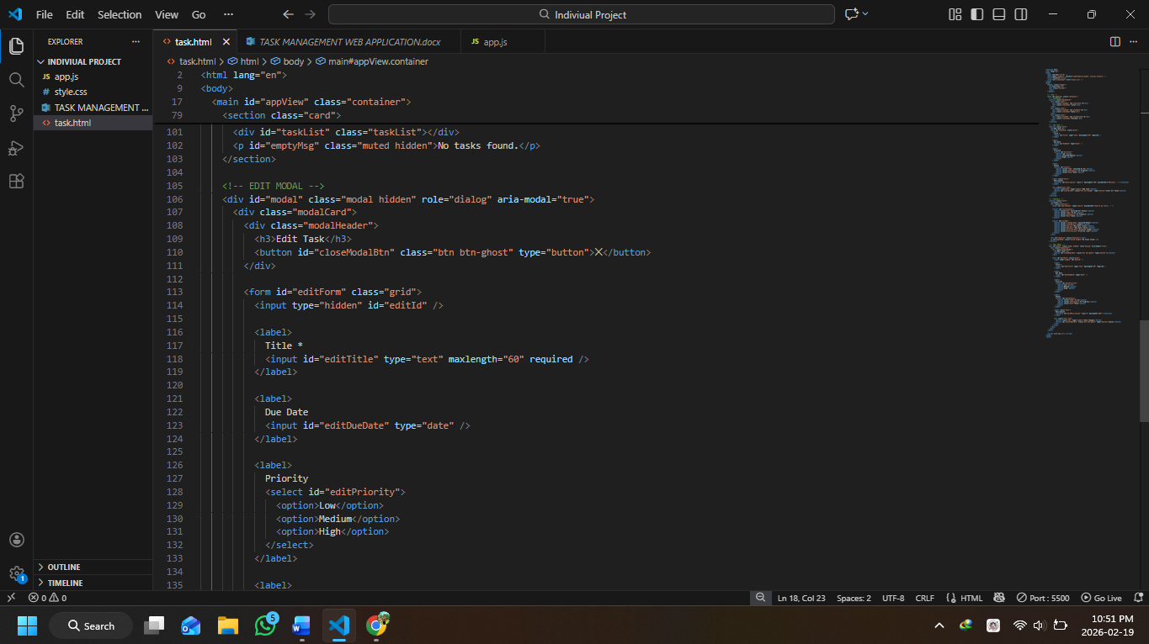

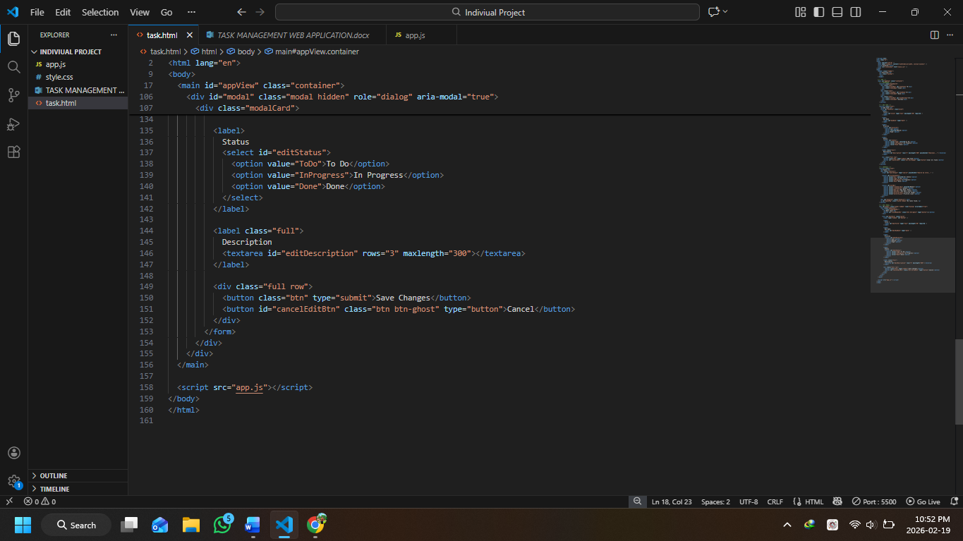

- CSS Code

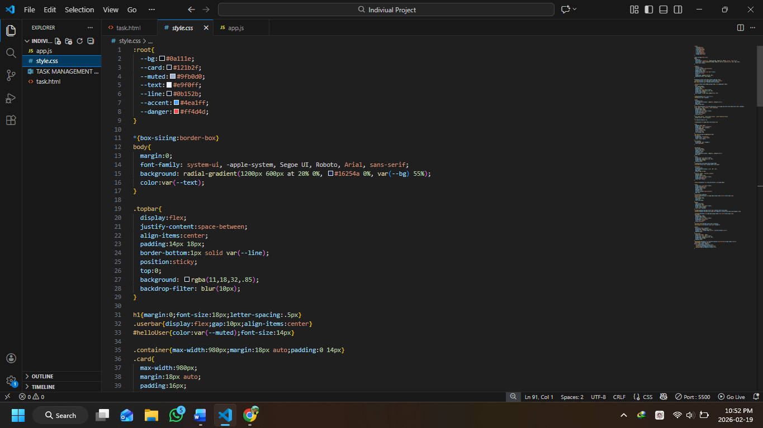

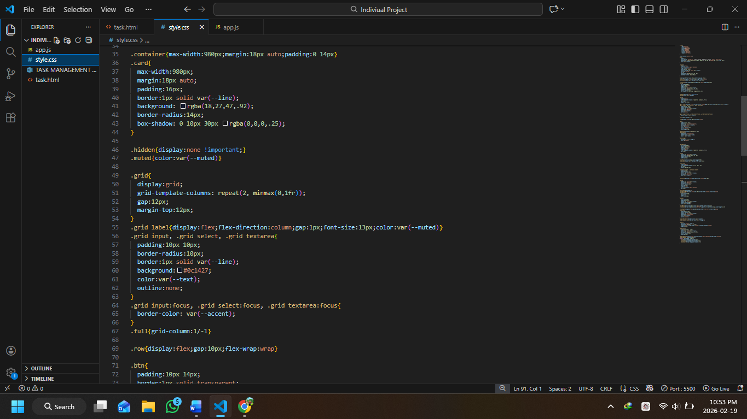

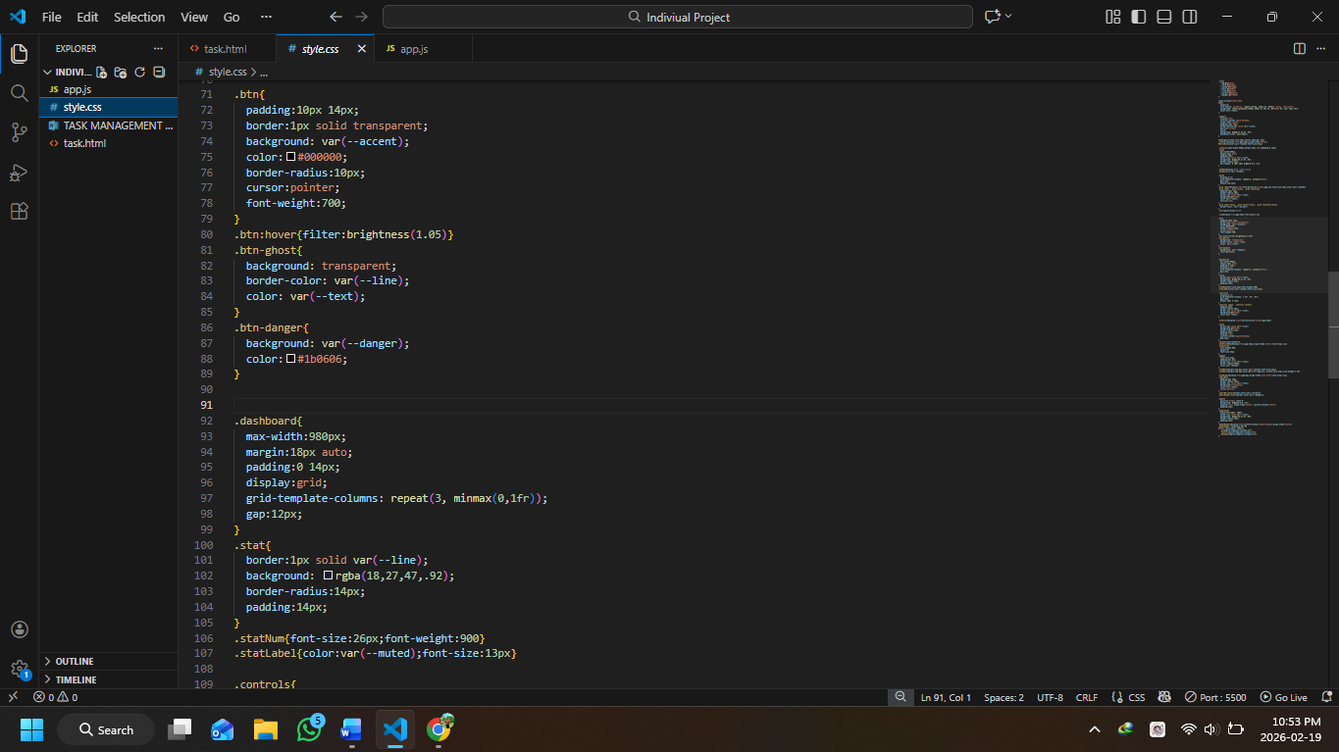

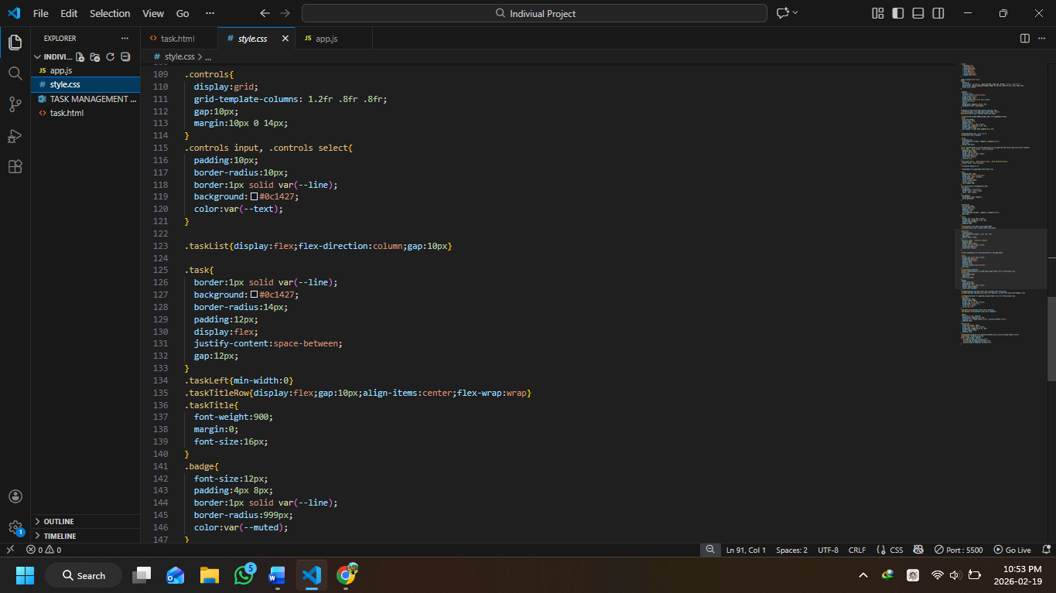

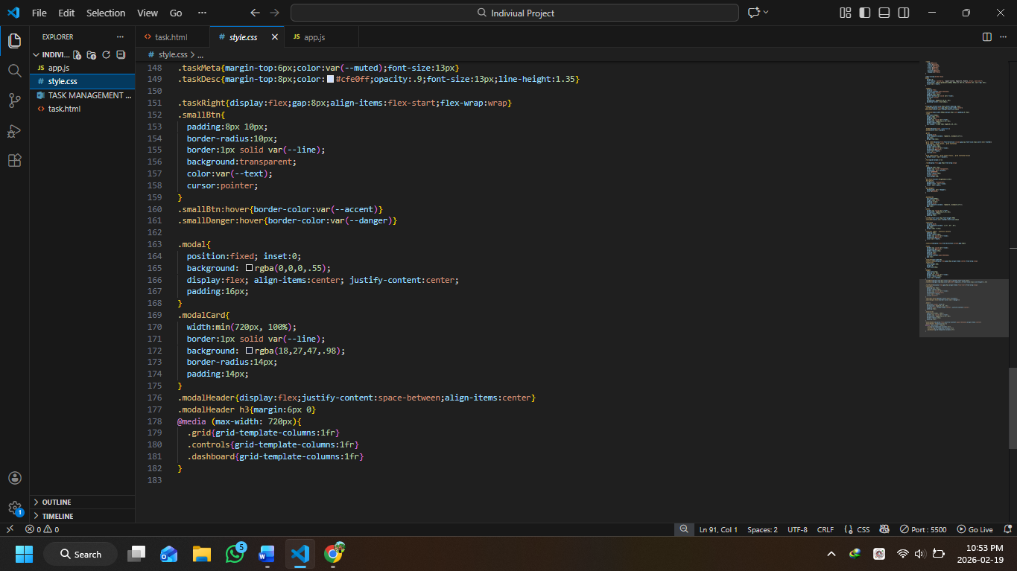

- JavaScript Code

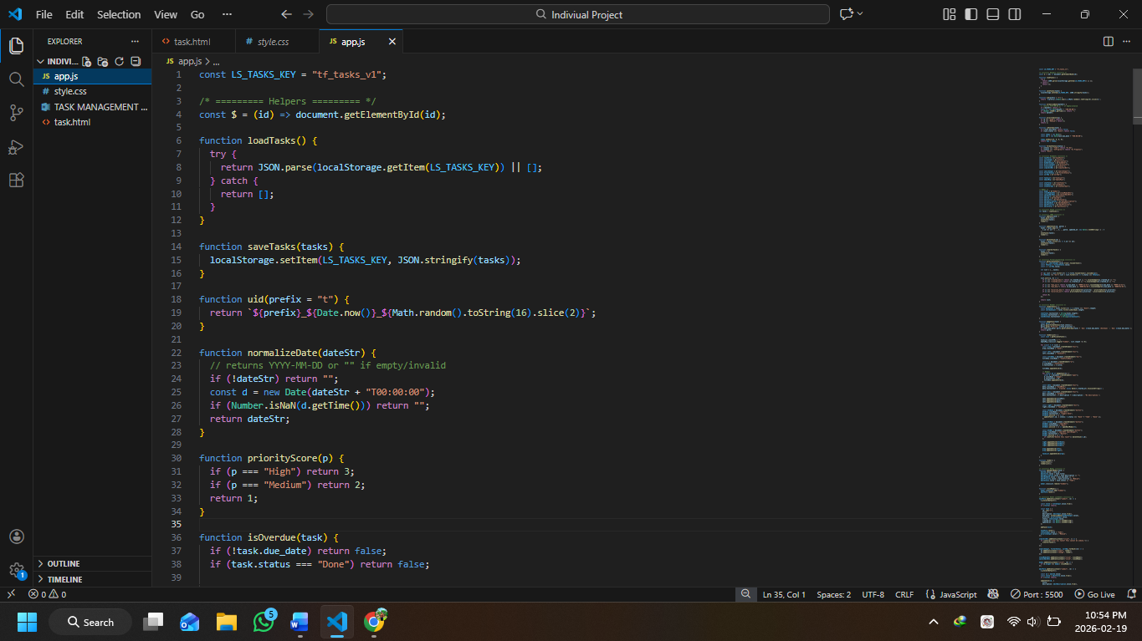

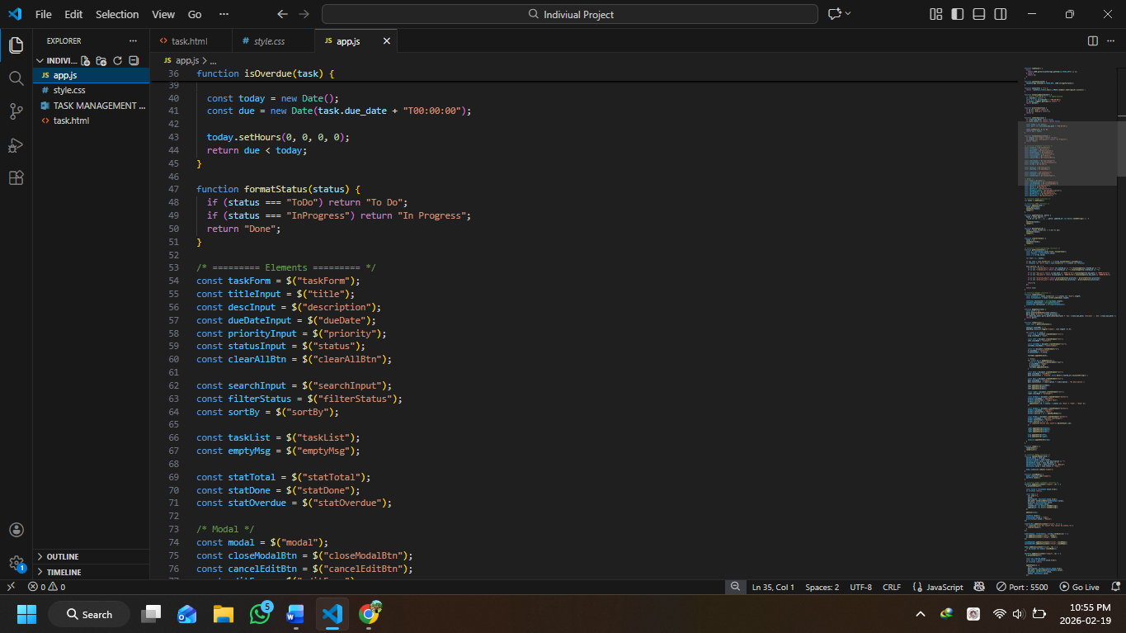

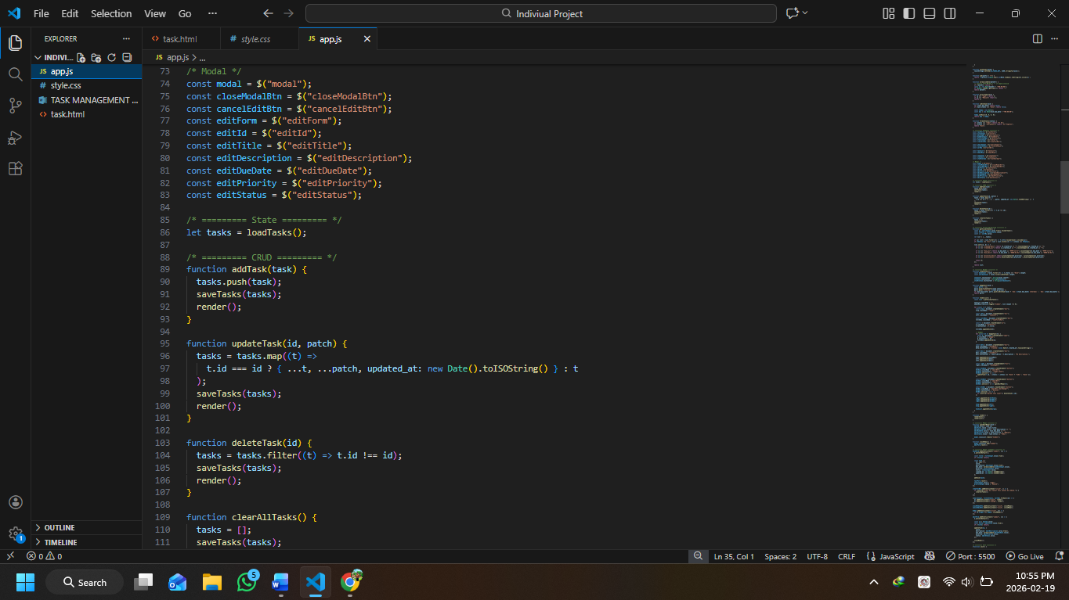

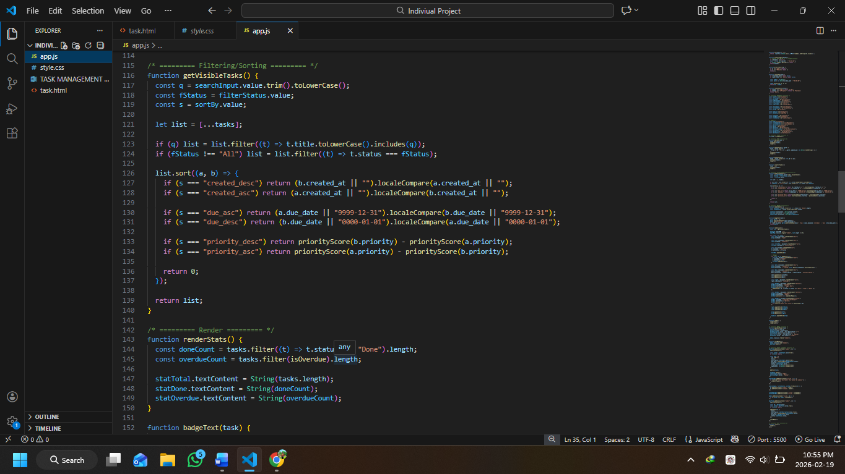

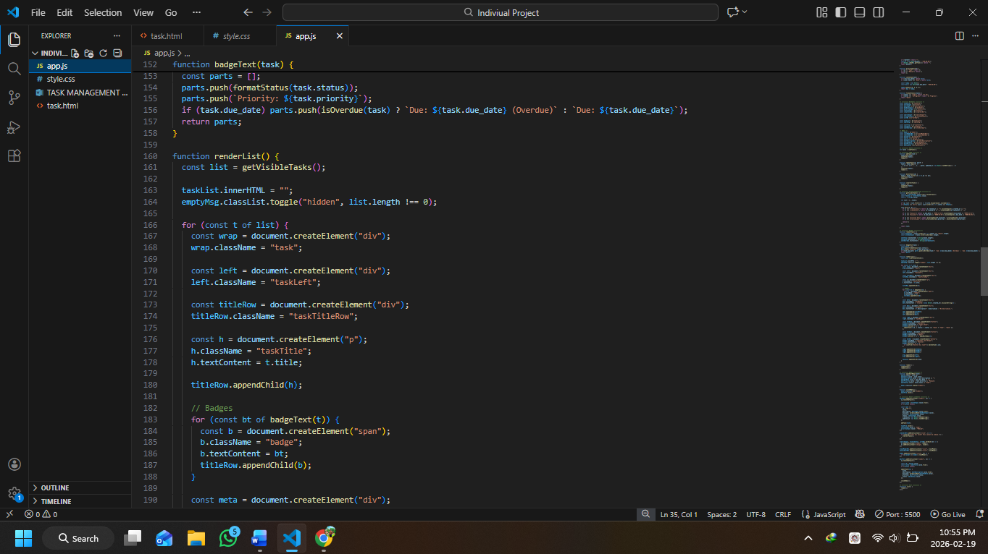

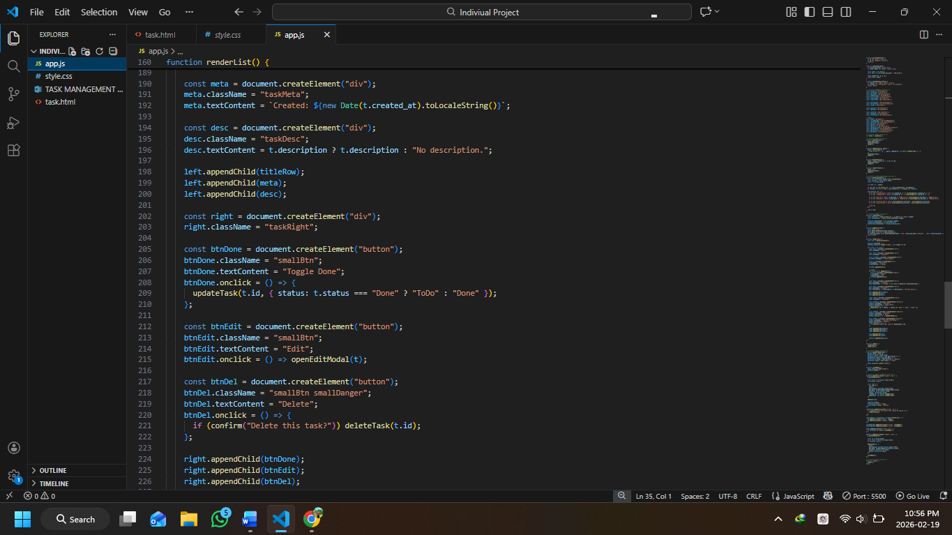

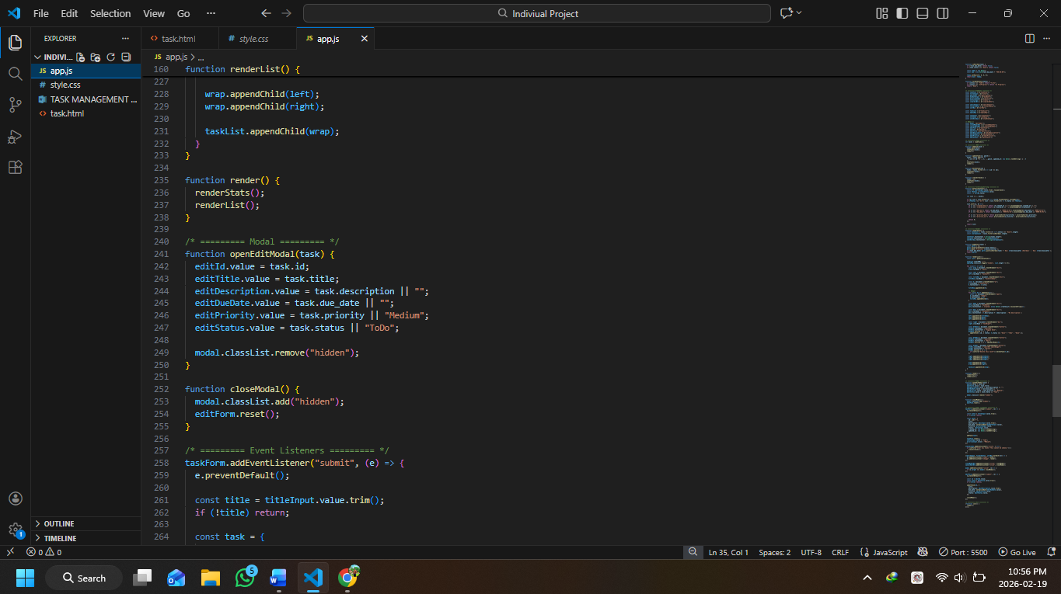

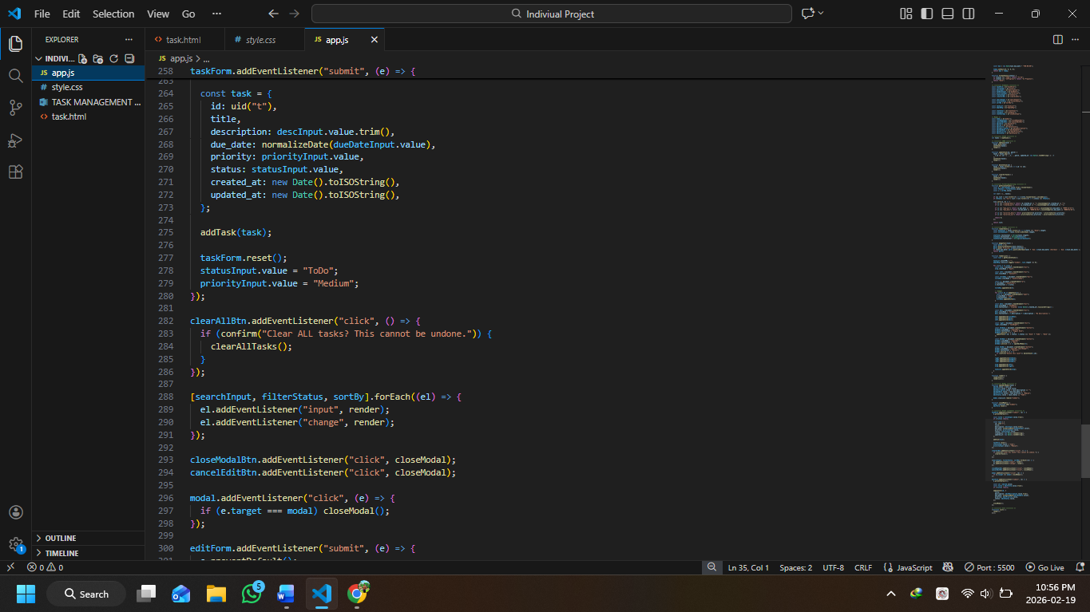

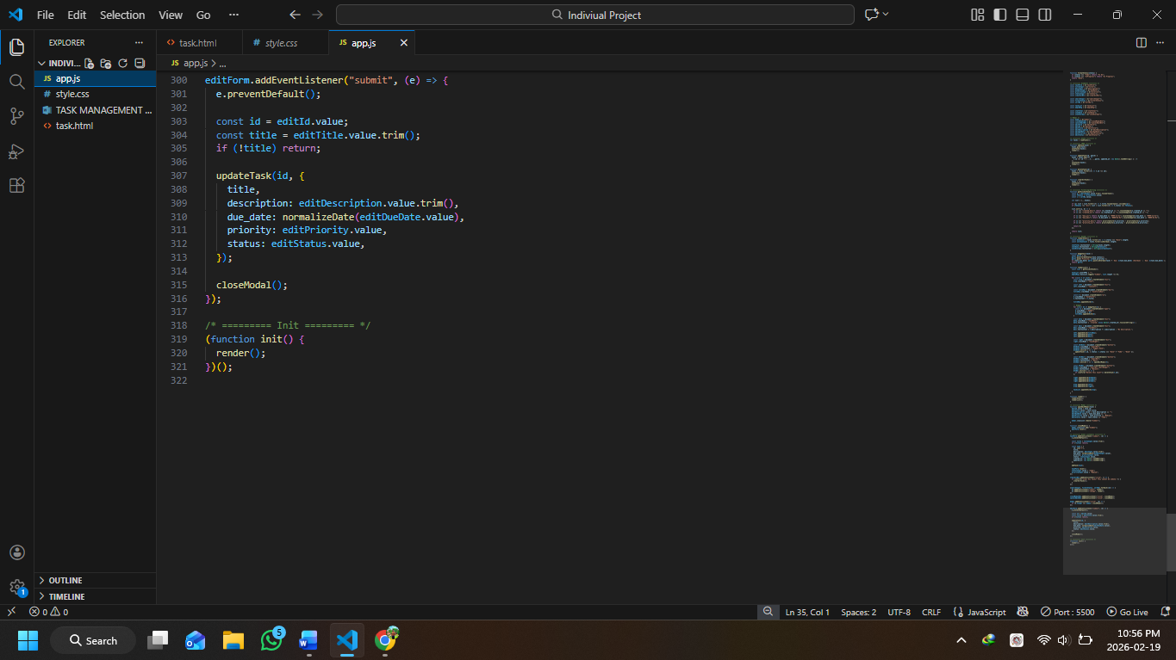

Project Web Page

